**COVID Vaccine Statewise**

**First Dashboard**

1] As per covid-19 India data I can easily identify first dose and second dose, Gender wise data, Age slab wise data and Covaxin, CoviShield & Sputnik V data.

2} In my first dashboard I represent Vaccine data age wise.

3} In this dash board you can easily filler data as per state wise.

4} In this Dashboard I used Clustered Column Chart to show the pivot chart of vaccination age wise.

5} in this dashboard I use insert slicer to represent State.

Below are the data which is use in dashboard

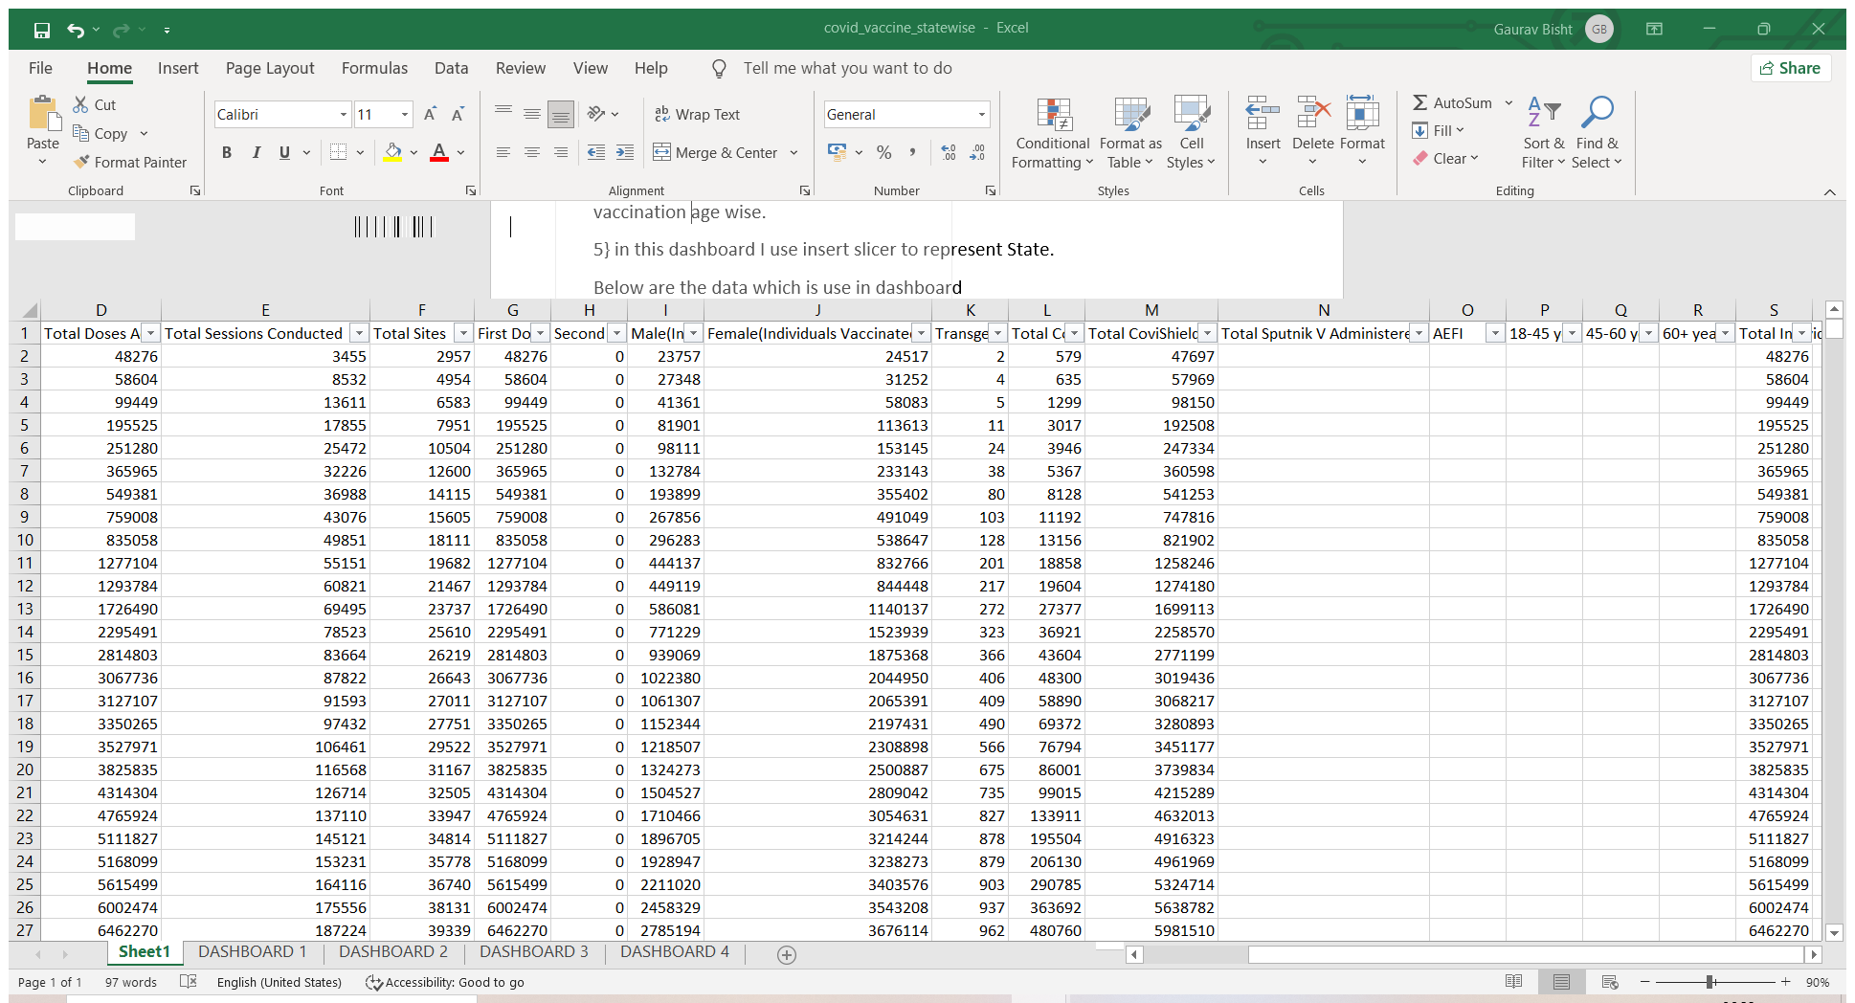

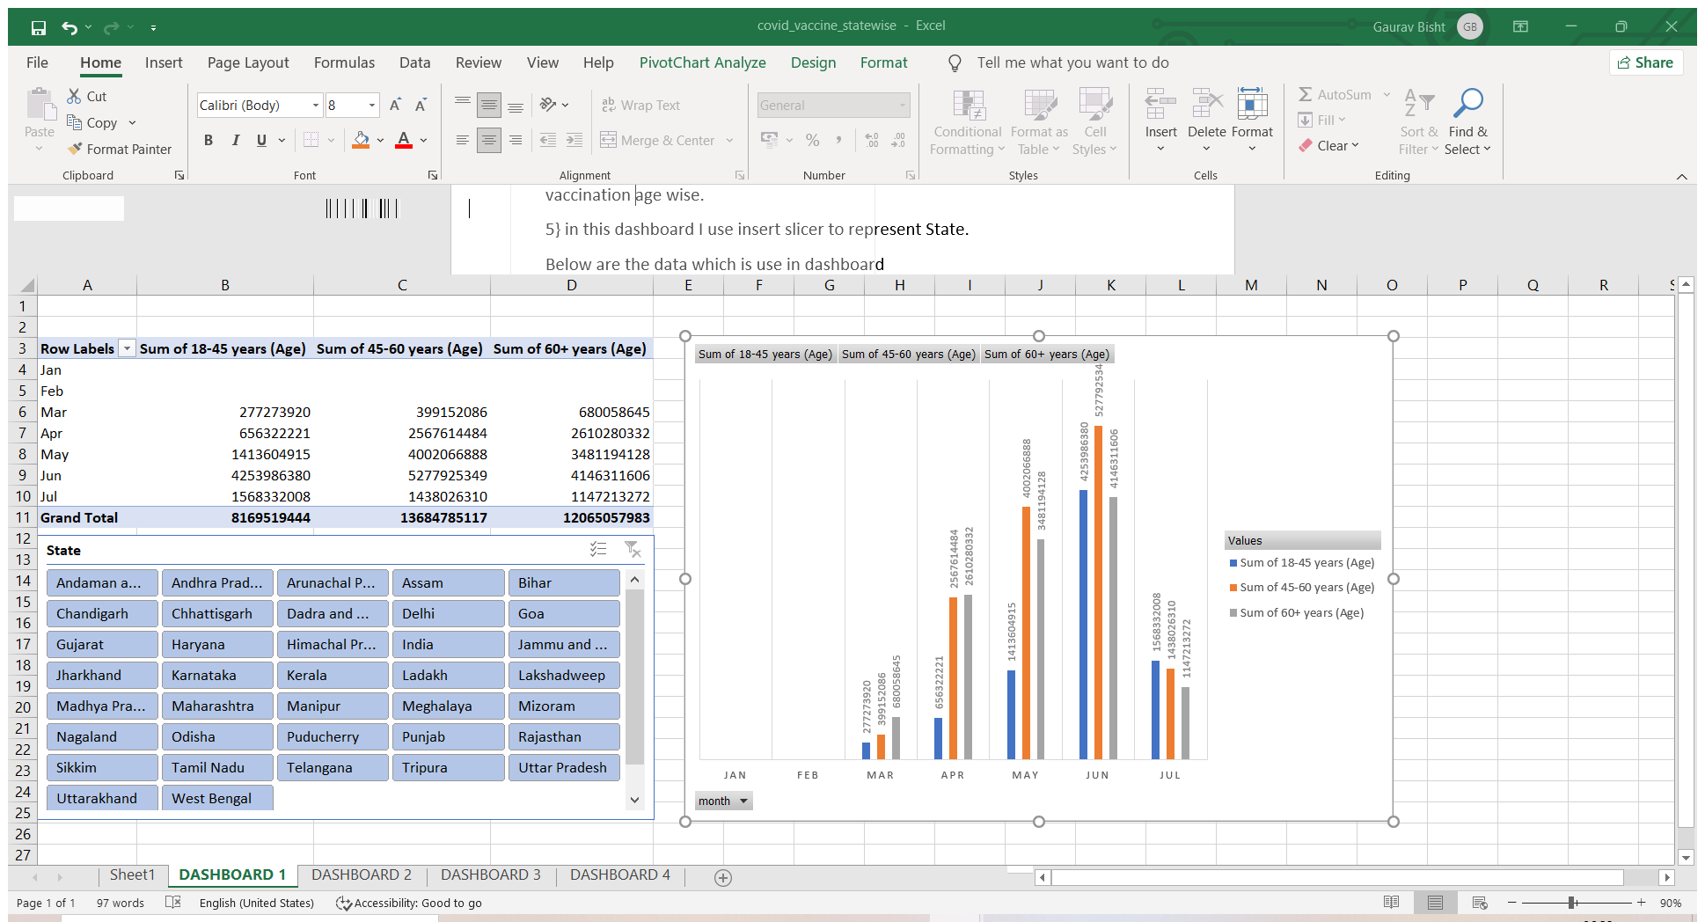

**Second Dashboard**

1] As per covid-19 India data I can easily identify first dose and second dose, Gender wise data, Age slab wise data and Covaxin, CoviShield & Sputnik V data.

2} In my first dashboard I represent Vaccine data Gender wise.

3} In this dash board you can easily filler data as per state wise.

4} In this Dashboard I used Clustered Bar Chart and Line with markers to show the pivot chart of vaccination gender wise.

5} in this dashboard I use insert slicer to represent State.

Below are the data which is use in dashboard



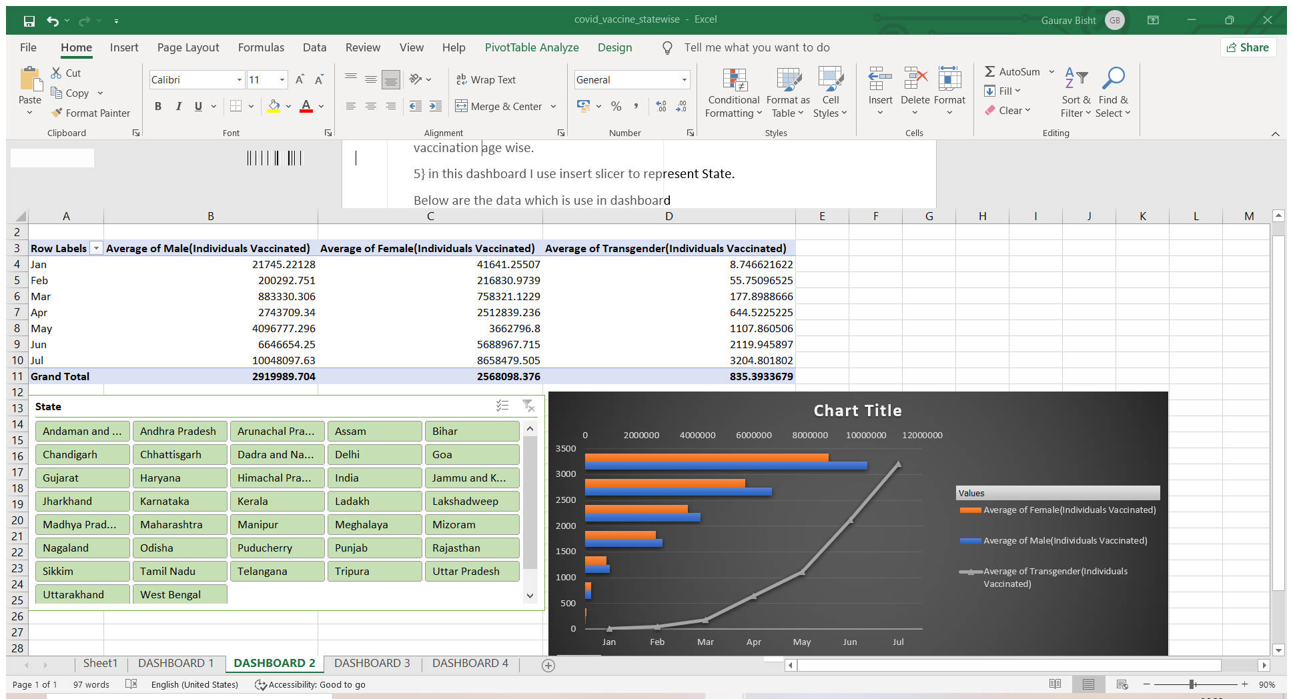

**Third Dashboard**

1] As per covid-19 India data I can easily identify first dose and second dose, Gender wise data, Age slab wise data and Covaxin, CoviShield & Sputnik V data.

2} In my first dashboard I represent Vaccine data by different company wise.

3} In this dash board you can easily filler data as per state wise.

4} In this Dashboard I used clustered bar to represent Sum of total Covaxin and Covid shield and Line with Markers to represent Sputnik.

5} in this dashboard I use insert slicer to represent State

Below are the data which is use in dashboard

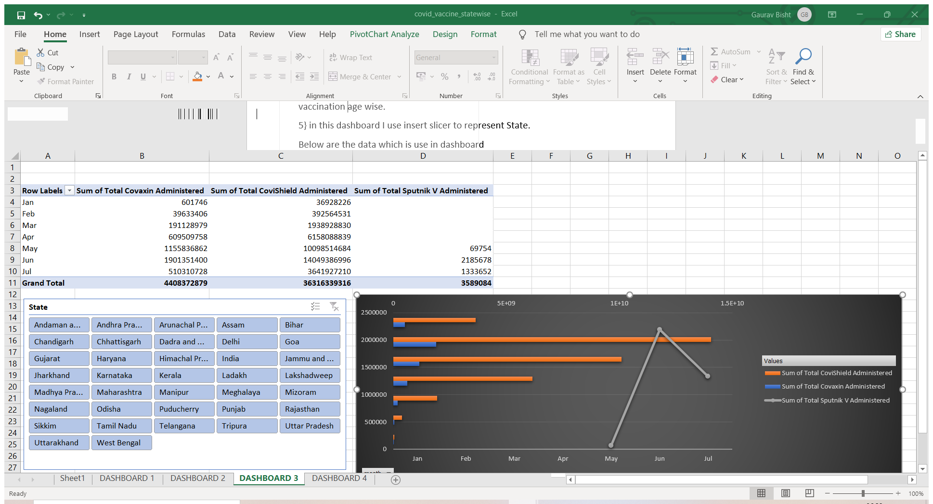

**Fourth Dashboard**

1] As per covid-19 India data I can easily identify first dose and second dose, Gender wise data, Age slab wise data and Covaxin, CoviShield & Sputnik V data.

2} In my first dashboard I represent Vaccine data by different company wise.

3} In this dash board you can easily filler data as per state wise.

4} In this Dashboard I used clustered column to represent Sum of total First dose and Second dose.

5} in this dashboard I use insert slicer to represent State

Below are the data which is use in dashboard



